**PROJECT HOMEWORK**

**DATABASE MANAGEMENT SYSTEMS**



**Creator:**

Ammar Ajam G231210554

Faculty of Computer and Information Sciences

Computer Engineering

Sakarya University

October-December 2024

**Summary**

This project involves designing a database schema for a hospital management system. The schema includes tables to manage users (patients, doctors, nurses, staff), their contact information, hospitals, cities, districts, departments, and appointments. It also tracks emergency contacts, insurance details, payments, prescriptions, and medications.

Key features:

* **Users**: Includes patients, doctors, and staff, linked to contact and hospital data.
* **Hospital and Departments**: Hospitals are associated with cities, districts, managers, and departments.
* **Appointments and Payments**: Manages patient-doctor appointments with statuses and linked payments.
* **Prescriptions and Medications**: Tracks prescribed medications with dosages, dates, and supplies.

Integrity is maintained with foreign key constraints and ON DELETE CASCADE for relational consistency. Constraints ensure valid data entries (e.g., dates, unique fields, and checks for proper values). The project implements default values, randomizations for prescriptions, and cascading deletes for efficient data management.

**Business Rules**

**Business Rules (Using only 1:M, 1:1, etc.):**

**users**

* 1:1 with contact_information (via user_id)
* 1:M with patient (user can be a patient or not?)
* 1:M with doctors/nurses/staff/managers (user can be one of these roles)

**contact_information**

* 1:1 with users (one contact info per user)

**managers**

* 1:1 with hospital
* 1:M with departments

**hospital**

* 1:1 with city
* 1:1 with district
* 1:1 with managers
* 1:M with departments

**city**

* 1:M with district
* 0:M with hospital

**district**

* 1:1 with city
* 0:M with hospital

**patient**

* 1:1 with users
* 1:M with appointments
* 1:M with payments
* 0:1 with insurance
* 0:M with emergency_contact

**doctors**

* 1:1 with users
* 1:M with appointments (a doctor can have many appointments)
* 1:1 with departments

**nurses**

* 1:1 with users
* 1:1 with departments

**staff**

* 1:1 with users
* 1:1 with departments

**departments**

* 1:1 with managers
* 1:M with doctors
* 1:M with nurses
* 1:M with staff
* 1:M with rooms

**appointments**

* 1:1 with patient
* 1:1 with doctor
* 1:1 with payments
* 1:1 with prescriptions
* 0:1 with room

**payments**

* 1:1 with appointments

**prescriptions**

* 1:1 with appointments
* 1:M with prescription_medications

**medications**

* 0:M with prescription_medications

**insurance**

* 1:1 with patient

**emergency_contact**

* 1:1 with patient

**prescription_medications** (junction table)

* M:M between prescriptions and medications

### Relational schema

### Users: user_id (Primary Key), first_name VARCHAR(30) NOT NULL, last_name VARCHAR(30) NOT NULL, gender CHAR(1) CHECK (gender IN ('M', 'F')) NOT NULL, date_of_birth DATE NOT NULL

### Contact_Information: contact_id (Primary Key), user_id INT REFERENCES Users(user_id) ON DELETE CASCADE, phone_number VARCHAR(11) NOT NULL UNIQUE, address VARCHAR(100) NOT NULL, email VARCHAR(50) NOT NULL UNIQUE

### City: city_id (Primary Key), name VARCHAR(30) NOT NULL UNIQUE

### District: district_id (Primary Key), name VARCHAR(30) NOT NULL UNIQUE

### Managers: manager_id (Primary Key)

### Hospital: hospital_id (Primary Key), city_id INT REFERENCES City(city_id) ON DELETE CASCADE, district_id INT REFERENCES District(district_id) ON DELETE CASCADE, manager_id INT REFERENCES

### Managers(manager_id) ON DELETE CASCADE, name VARCHAR(30) NOT NULL, address VARCHAR(30) NOT NULL UNIQUE, phone_number VARCHAR(30) NOT NULL UNIQUE, email VARCHAR(30) NOT NULL UNIQUE

### Patient: patient_id INT PRIMARY KEY REFERENCES Users(user_id) ON DELETE CASCADE, balance INT NOT NULL DEFAULT 100 CHECK(balance >= 0)

### Emergency_Contact: em_con_id SERIAL PRIMARY KEY, patient_id INT REFERENCES Patient(patient_id) ON DELETE CASCADE, first_name VARCHAR(30) NOT NULL, last_name VARCHAR(30) NOT NULL, gender CHAR(1) CHECK (gender IN ('M', 'F')) NOT NULL, date_of_birth DATE NOT NULL CHECK (date_of_birth <= CURRENT_DATE), relationship VARCHAR(30) NOT NULL, phone_number VARCHAR(11) NOT NULL UNIQUE, address VARCHAR(100) NOT NULL, email VARCHAR(50) NOT NULL UNIQUE

### Insurance: insurance_id SERIAL PRIMARY KEY, patient_id INT REFERENCES Patient(patient_id) ON DELETE CASCADE, insurance_provider VARCHAR(30) NOT NULL, policy_number VARCHAR(5) NOT NULL CHECK (LENGTH(policy_number) = 5), coverage_amount INT NOT NULL

### Departments: department_id SERIAL PRIMARY KEY, hospital_id INT REFERENCES Hospital(hospital_id) ON DELETE CASCADE, manager_id INT REFERENCES Managers(manager_id) ON DELETE CASCADE, name VARCHAR(20) NOT NULL UNIQUE, description VARCHAR(255), phone_number INT NOT NULL UNIQUE

### Doctors: doctor_id INT PRIMARY KEY REFERENCES Users(user_id) ON DELETE CASCADE, department_id INT REFERENCES Departments(department_id) ON DELETE CASCADE, license_id INT NOT NULL

### Staff: staff_id INT PRIMARY KEY REFERENCES Users(user_id) ON DELETE CASCADE, department_id INT REFERENCES Departments(department_id) ON DELETE CASCADE, role VARCHAR(255) NOT NULL

### Nurses: nurse_id INT PRIMARY KEY REFERENCES Users(user_id) ON DELETE CASCADE

### Appointments: appointment_id SERIAL PRIMARY KEY, patient_id INT REFERENCES Patient(patient_id) ON DELETE CASCADE, doctor_id INT REFERENCES Doctors(doctor_id) ON DELETE CASCADE, app_date DATE NOT NULL CHECK (app_date > CURRENT_DATE), app_status CHAR(2) CHECK (app_status IN ('SC', 'CO', 'CA'))

### Payments: payment_id SERIAL PRIMARY KEY, appointment_id INT REFERENCES Appointments(appointment_id), amount INT NOT NULL

### Prescriptions: prescription_id SERIAL PRIMARY KEY, appointment_id INT REFERENCES Appointments(appointment_id) ON DELETE CASCADE, dosage INT NOT NULL DEFAULT 5 + (FLOOR(RANDOM() * 6))::INT, start_date DATE NOT NULL DEFAULT CURRENT_DATE, end_date DATE NOT NULL DEFAULT CURRENT_DATE + (5 + FLOOR(RANDOM() * 4))::INT

### Prescription_Medications: pres_med_id SERIAL PRIMARY KEY, prescription_id INT REFERENCES Prescriptions(prescription_id) ON DELETE CASCADE, medication_id INT REFERENCES Medications(medication_id) ON DELETE CASCADE

### Medications: medication_id SERIAL PRIMARY KEY, name VARCHAR(30) UNIQUE, administration_method VARCHAR(30) NOT NULL DEFAULT 'Oral', manufacturer VARCHAR(255) NOT NULL DEFAULT 'medixCor', expiry_date DATE NOT NULL DEFAULT CURRENT_DATE, supply INT NOT NULL DEFAULT 1000000

Database Schema

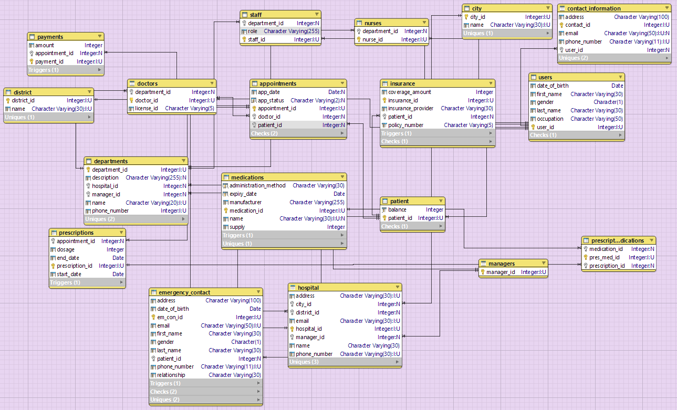

**Crow’s Foot Diagram**

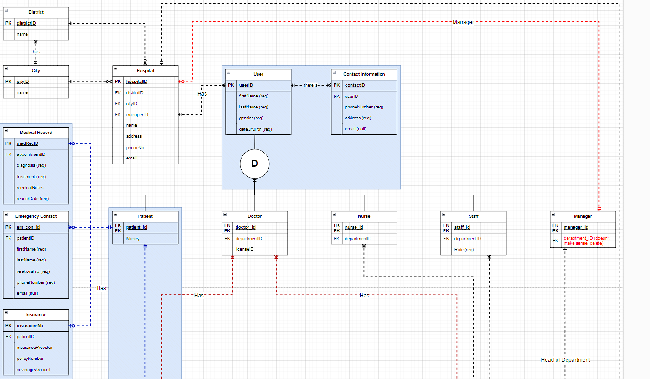 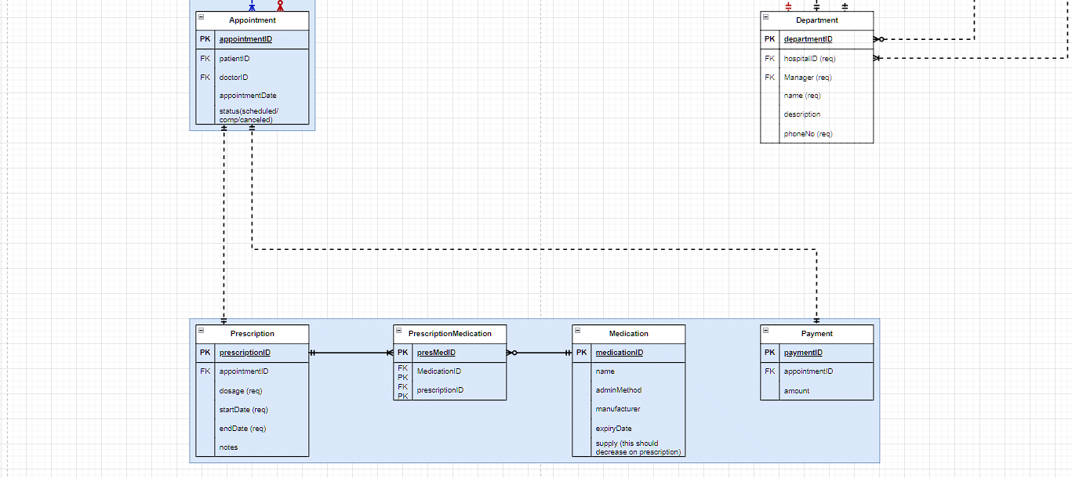

**Triggers**

**1. Trigger: trigger_set_payment_amount**

* Ensures the correct payment amount is assigned to the payments table before inserting a record. The amount depends on the department of the doctor associated with the appointment.
* Fetches the department name from the departments table, based on the appointment's doctor.
* Sets payment amounts based on predefined rules:
  + 50 for "Gastroenterology."
  + 75 for "Phlebotomy."
  + 25 for "Dermatology."
* If the department name is unrecognized, it raises an exception.

**2. Trigger: set_random_values**

* Automatically assigns random values to the fields of a new medications record before insertion.
* Assigns:
  + A random administration_method (e.g., "Oral," "Injection").
  + A random manufacturer (e.g., "PharmaCorp").
  + A random name (e.g., "Healzyme").
  + A random expiry date between 1 and 2 years from the current date.
* Ensures diverse, realistic medication data in the database.

**3. Trigger: after_prescription_insert**

* Executes after a new prescription is inserted into the prescriptions table.
* Automatically:
  + Selects a random medication from the medications table.
  + Reduces the medication's supply by the dosage specified in the prescription.
  + Inserts a relationship between the prescription and the medication into the prescription_medications table.
* Maintains medication supply and automates linking prescriptions to medications.

**4. Trigger: after_insert_insurance**

* Executes after a new insurance record is inserted into the insurance table.
* Automatically updates the patient’s balance by adding the insurance coverage amount to their existing balance.
* Ensures real-time updates to patient financial data.

**5. Trigger: enforce_max_emergency_contacts_trigger**

* Prevents a patient from having more than 5 emergency contacts.
* Checks the number of emergency contacts associated with the patient before inserting a new record into the emergency_contact table.
* If the count is 5 or more, it raises an exception.

**Procedures**

**1. Procedure: add_new_user**

* Adds a new patient to the system by creating records in the users, contact_information, and patient tables.
* Inserts basic details (e.g., first_name, last_name, gender, date_of_birth) into the users table.
* Retrieves the newly created user_id and uses it to insert contact information (phone_number, address, email).
* Inserts the user_id into the patient table to link the user as a patient.

**2. Procedure: book_new_appointment**

* Books an appointment for a patient with a specific doctor on a specified date.
* Inserts a record into the appointments table with the provided patient_id, doctor_id, app_date, and app_status.
* Retrieves the appointment_id of the new appointment.
* Inserts a corresponding record into the payments table. The payment amount is assigned by the trigger_set_payment_amount.

**3. Procedure: add_emergency_contact**

* Adds an emergency contact for a specific patient.
* Inserts a record into the emergency_contact table with the contact’s details (e.g., first_name, last_name, gender, date_of_birth, relationship, phone_number, address, email).
* Relies on the enforce_max_emergency_contacts_trigger to ensure no patient exceeds 5 emergency contacts.

**4. Procedure: process_appointment**

* Handles payment and prescription generation for an appointment.
* Retrieves:
  + The patient’s ID.
  + Payment amount.
  + Appointment status.
* Checks if the appointment is already completed. If it is, an exception is raised.
* Retrieves the patient’s balance and verifies if it is sufficient to cover the payment:
  + If sufficient:
    - Deducts the payment from the patient’s balance.
    - Marks the appointment status as completed (CO).
    - Calls the generate_prescription procedure to create a prescription.
  + If insufficient:
    - Raises an exception indicating the patient’s balance is insufficient.

**CRUD Operations**

You can **CREATE/UPDATE/DELETE** on some tables (within what makes sense in a hospital system) like adding a new patient, appointment, emergency contact, etc.

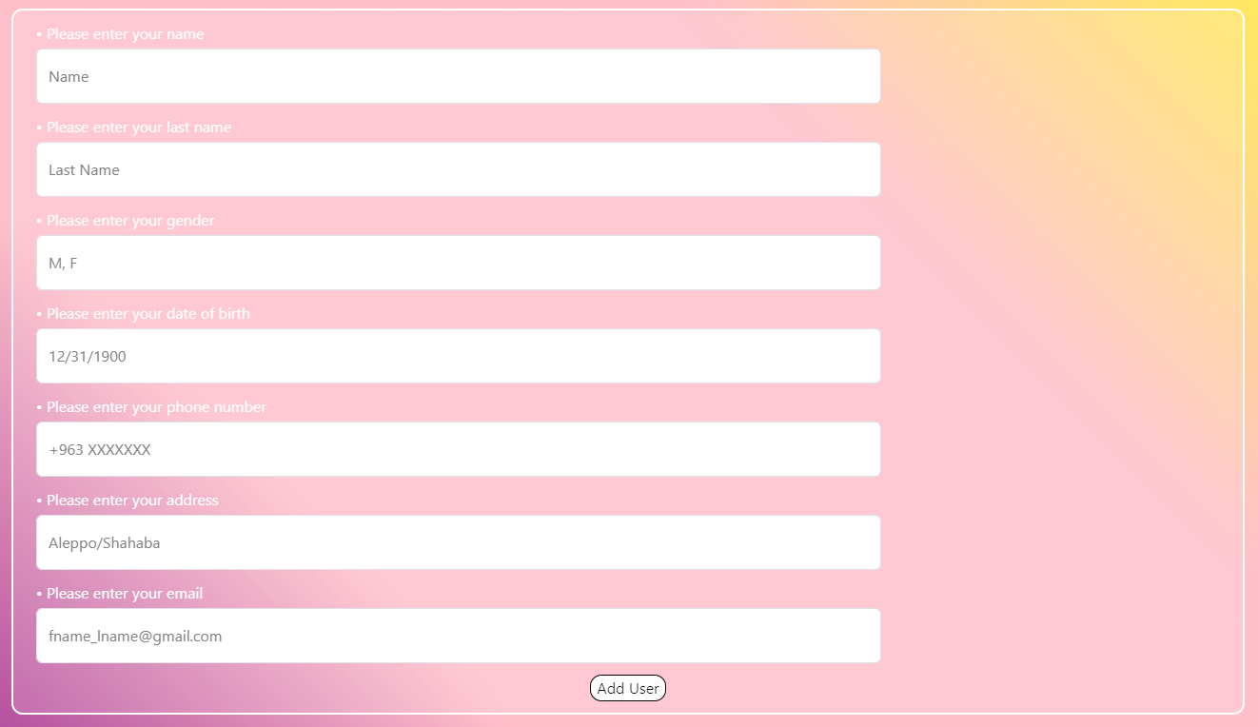

You can **READ** from ALL tables, based on its own columns.

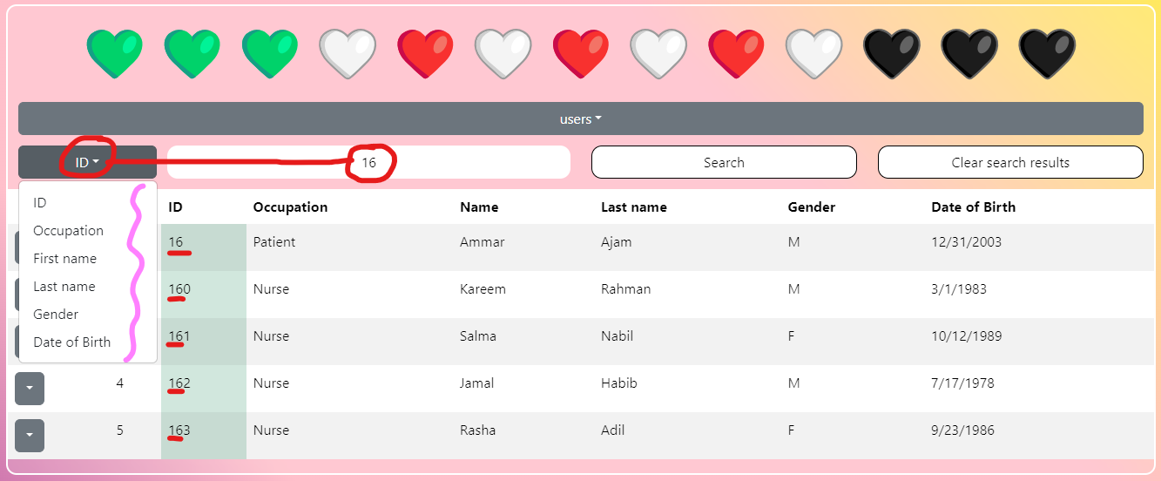

**Source codes**

https://github.com/DarkAndLighto/DatabaseManagementSystems

CREATE TABLE users (

user_id SERIAL PRIMARY KEY,

first_name VARCHAR(30) NOT NULL,

last_name VARCHAR(30) NOT NULL,

gender CHAR(1) CHECK (gender IN ('M', 'F')) NOT NULL,

date_of_birth DATE NOT NULL

);

CREATE TABLE contact_information (

contact_id SERIAL PRIMARY KEY,

user_id INT REFERENCES users(user_id) ON DELETE CASCADE,

phone_number VARCHAR(11) NOT NULL UNIQUE,

address VARCHAR(100) NOT NULL,

email VARCHAR(50) NOT NULL UNIQUE

);

CREATE TABLE hospital (

hospital_id SERIAL PRIMARY KEY,

city_id INT REFERENCES city(city_id) ON DELETE CASCADE NOT NULL,

district_id INT REFERENCES district(district_id) ON DELETE CASCADE NOT NULL,

manager_id INT REFERENCES managers(manager_id) ON DELETE CASCADE NOT NULL,

name VARCHAR(30) NOT NULL,

address VARCHAR(30) NOT NULL UNIQUE,

phone_number VARCHAR(30) NOT NULL UNIQUE,

email VARCHAR(30) NOT NULL UNIQUE

);

CREATE TABLE city (

city_id SERIAL PRIMARY KEY,

name VARCHAR(30) NOT NULL UNIQUE

);

CREATE TABLE district (

district_id SERIAL PRIMARY KEY,

name VARCHAR(30) NOT NULL UNIQUE

);

CREATE TABLE patient(

patient_id INT PRIMARY KEY REFERENCES users(user_id) ON DELETE CASCADE,

balance INT NOT NULL DEFAULT 100 CHECK(balance >= 0)

);

ALTER TABLE patient

ADD COLUMN balance INT NOT NULL DEFAULT 100 CHECK(balance >= 0);

DROP COLUMN balance;

CREATE TABLE emergency_contact(

em_con_id SERIAL PRIMARY KEY,

patient_id INT REFERENCES patient(patient_id) ON DELETE CASCADE,

first_name VARCHAR(30) NOT NULL,

last_name VARCHAR(30) NOT NULL,

gender CHAR(1) CHECK (gender IN ('M', 'F')) NOT NULL,

date_of_birth DATE NOT NULL CHECK (date_of_birth <= CURRENT_DATE),

relationship VARCHAR(30) NOT NULL,

phone_number VARCHAR(11) NOT NULL UNIQUE,

address VARCHAR(100) NOT NULL,

email VARCHAR(50) NOT NULL UNIQUE

);

CREATE TABLE insurance(

insurance_id SERIAL PRIMARY KEY,

patient_id INT REFERENCES patient(patient_id) ON DELETE CASCADE,

insurance_provider VARCHAR(30) NOT NULL,

policy_number VARCHAR(5) NOT NULL CHECK (length(policy_number) = 5),

coverage_amount INT NOT NULL

);

CREATE TABLE departments(

department_id SERIAL PRIMARY KEY,

hospital_id INT REFERENCES hospital(hospital_id) ON DELETE CASCADE,

manager_id INT REFERENCES managers(manager_id) ON DELETE CASCADE,

name VARCHAR(20) NOT NULL UNIQUE,

description VARCHAR(255),

phone_number INT NOT NULL UNIQUE

);

CREATE TABLE managers(

manager_id SERIAL PRIMARY KEY

);

CREATE TABLE doctors(

doctor_id INT PRIMARY KEY REFERENCES users(user_id) ON DELETE CASCADE,

department_id INT REFERENCES departments(department_id) ON DELETE CASCADE,

license_id INT NOT NULL

);

CREATE TABLE staff(

staff_id INT PRIMARY KEY REFERENCES users(user_id) ON DELETE CASCADE,

department_id INT REFERENCES departments(department_id) ON DELETE CASCADE,

role VARCHAR(255) NOT NULL

);

CREATE TABLE nurses(

nurse_id INT PRIMARY KEY REFERENCES users(user_id) ON DELETE CASCADE

);

CREATE TABLE appointments(

appointment_id SERIAL PRIMARY KEY,

patient_id INT REFERENCES patient(patient_id) ON DELETE CASCADE,

doctor_id INT REFERENCES doctors(doctor_id) ON DELETE CASCADE,

app_date data NOT NULL CHECK (app_date > CURRENT_DATE),

app_status char(2) CHECK (app_status IN ('SC', 'CO', 'CA'))

);

select * from appointments;

ALTER TABLE appointments

ADD CONSTRAINT app_date CHECK (app_date > CURRENT_DATE);

CREATE TABLE payments(

payment_id SERIAL PRIMARY KEY,

appointment_id INT REFERENCES appointments(appointment_id),

amount INT NOT NULL

);

DROP TABLE prescriptions;

CREATE TABLE prescriptions (

prescription_id SERIAL PRIMARY KEY,

appointment_id INT REFERENCES appointments(appointment_id) ON DELETE CASCADE,

dosage INT NOT NULL DEFAULT 5 + (FLOOR(RANDOM() * 6))::INT,

start_date DATE NOT NULL DEFAULT CURRENT_DATE,

end_date DATE NOT NULL DEFAULT CURRENT_DATE + (5 + FLOOR(RANDOM() * 4))::INT

);

DROP TABLE prescription_medications;

CREATE TABLE prescription_medications(

pres_med_id SERIAL PRIMARY KEY,

prescription_id INT REFERENCES prescriptions(prescription_id) ON DELETE CASCADE,

medication_id INT REFERENCES medications(medication_id) ON DELETE CASCADE

);

DROP TABLE medications;

CREATE TABLE medications(

medication_id SERIAL PRIMARY KEY,

name VARCHAR(30) UNIQUE,

administration_method VARCHAR(30) NOT NULL DEFAULT 'Oral',

manufacturer VARCHAR(255) NOT NULL DEFAULT 'medixCor',

expiry_date DATE NOT NULL DEFAULT CURRENT_DATE,

supply int NOT NULL DEFAULT 1000000

);

CREATE OR REPLACE FUNCTION set_payment_amount()

RETURNS TRIGGER AS $$

DECLARE

department_name VARCHAR(20);

BEGIN

-- Retrieve the department name based on the appointment's doctor

SELECT d.name

INTO department_name

FROM appointments a

JOIN doctors doc ON a.doctor_id = doc.doctor_id

JOIN departments d ON doc.department_id = d.department_id

WHERE a.appointment_id = NEW.appointment_id;

-- Set the payment amount based on the department

CASE department_name

WHEN 'Gastroenterology' THEN NEW.amount := 50;

WHEN 'Phlebotomy' THEN NEW.amount := 75;

WHEN 'Dermatology' THEN NEW.amount := 25;

ELSE RAISE EXCEPTION 'Unknown department: %', department_name;

END CASE;

RETURN NEW;

END;

$$ LANGUAGE plpgsql;

CREATE TRIGGER trigger_set_payment_amount

BEFORE INSERT ON payments

FOR EACH ROW

EXECUTE FUNCTION set_payment_amount();

CREATE OR REPLACE PROCEDURE generate_prescription(

IN new_appointment_id INT

)

LANGUAGE plpgsql

AS $$

BEGIN

-- Insert a new prescription entry for the provided appointment ID

INSERT INTO prescriptions (appointment_id)

VALUES (new_appointment_id);

-- Return success message for logging/debugging

RAISE NOTICE 'Prescription generated for appointment ID %.', new_appointment_id;

END;

$$;

drop FUNCTION assign_random_values_to_medications;

CREATE OR REPLACE FUNCTION assign_random_values_to_medications()

RETURNS TRIGGER AS $$

DECLARE

admin_methods TEXT[] := ARRAY['Oral', 'Injection', 'Topical', 'Inhalation'];

manufacturers TEXT[] := ARRAY['PharmaCorp', 'MediSupply', 'HealthPlus', 'BioLife'];

medication_names TEXT[] := ARRAY[

'Panacea', 'Medica', 'CuraTab', 'Healzyme', 'TheraMax',

'ReliefX', 'VitaPlus', 'NeuroAid', 'ImmunoCare', 'CardioFit'

];

year_offset INT;

BEGIN

-- Assign random values for each field

NEW.administration_method := admin_methods[ceil(random() * array_length(admin_methods, 1))::int];

NEW.manufacturer := manufacturers[ceil(random() * array_length(manufacturers, 1))::int];

NEW.name := medication_names[ceil(random() * array_length(medication_names, 1))::int];

-- Calculate random expiry date

year_offset := (1 + ceil(random() * 1)::int); -- Randomly choose 1 or 2 years

NEW.expiry_date := CURRENT_DATE + (interval '1 year' * year_offset);

RETURN NEW;

END;

$$ LANGUAGE plpgsql;

CREATE TRIGGER set_random_values

BEFORE INSERT ON medications

FOR EACH ROW

EXECUTE FUNCTION assign_random_values_to_medications();

CREATE OR REPLACE FUNCTION after_insert_prescription()

RETURNS TRIGGER AS $$

DECLARE

random_medication_id INT;

dosage INT := NEW.dosage;

BEGIN

--select a random medication

SELECT medication_id INTO random_medication_id

FROM medications

ORDER BY random()

LIMIT 1;

---Update the supply of the selected medication

UPDATE medications

SET supply = supply - dosage

WHERE medication_id = random_medication_id;

-- Insert the relation into prescription_medications

INSERT INTO prescription_medications(prescription_id, medication_id)

VALUES (NEW.prescription_id, random_medication_id);

RETURN NEW;

END;

$$ LANGUAGE plpgsql;

CREATE TRIGGER after_prescription_insert

AFTER INSERT ON prescriptions

FOR EACH ROW

EXECUTE FUNCTION after_insert_prescription();

CREATE OR REPLACE FUNCTION after_insert_insurance()

RETURNS TRIGGER AS $$

BEGIN

-- Update the patient's balance

UPDATE patient

SET balance = balance + NEW.coverage_amount

WHERE patient.patient_id = NEW.patient_id;

RETURN NEW;

END;

$$ LANGUAGE plpgsql;

CREATE TRIGGER after_insert_insurance

AFTER INSERT ON insurance

FOR EACH ROW

EXECUTE FUNCTION after_insert_insurance();

CREATE OR REPLACE FUNCTION enforce_max_emergency_contacts()

RETURNS TRIGGER AS $$

BEGIN

-- Check the current number of emergency contacts for the patient

IF (SELECT COUNT(*) FROM emergency_contact WHERE patient_id = NEW.patient_id) >= 5 THEN

RAISE EXCEPTION 'A patient can have a maximum of 5 emergency contacts.';

END IF;

RETURN NEW;

END;

$$ LANGUAGE plpgsql;

CREATE TRIGGER enforce_max_emergency_contacts_trigger

BEFORE INSERT ON emergency_contact

FOR EACH ROW

EXECUTE FUNCTION enforce_max_emergency_contacts();

/* This should be add_new_patient**   */

CREATE OR REPLACE PROCEDURE add_new_user(

    IN first_name TEXT,

    IN last_name TEXT,

    IN gender CHAR,

    IN date_of_birth DATE,

    IN phone_number INT,

    IN address TEXT,

    IN email TEXT

)

LANGUAGE plpgsql

AS $$

DECLARE

    new_user_id INT;

BEGIN

    INSERT INTO users(occupation, first_name, last_name, gender, date_of_birth)

    VALUES ('Patient', first_name, last_name, gender, date_of_birth)

    RETURNING user_id INTO new_user_id;

    INSERT INTO contact_information(user_id, phone_number, address, email)

    VALUES (new_user_id, phone_number, address, email);

    INSERT INTO patient(patient_id)

    VALUES (new_user_id);

END $$;

drop procedure book_new_appointment;

CREATE OR REPLACE PROCEDURE book_new_appointment(

    IN patient_id INT,

    IN doctor_id INT,

    IN app_date DATE,

    IN app_status CHAR(2)

)

LANGUAGE plpgsql

AS $$

DECLARE

    new_appointment_id INT;

BEGIN

    -- Insert into appointments and retrieve the ID

    INSERT INTO appointments(patient_id, doctor_id, app_date, app_status)

    VALUES (patient_id, doctor_id, app_date, app_status)

    RETURNING appointment_id INTO new_appointment_id;

    -- Insert into payments (amount will be set by the trigger)

    INSERT INTO payments(appointment_id)

    VALUES (new_appointment_id);

END;

$$;

CREATE OR REPLACE PROCEDURE add_emergency_contact(

    IN patient_id INT,

    IN first_name TEXT,

    IN last_name TEXT,

    IN gender CHAR,

    IN date_of_birth DATE,

    IN relationship TEXT,

    IN phone_number TEXT,

    IN address TEXT,

    IN email TEXT

)

LANGUAGE plpgsql

AS $$

BEGIN

    INSERT INTO emergency_contact (patient_id, first_name, last_name, gender, date_of_birth, relationship, phone_number, address, email)

    VALUES (patient_id, first_name, last_name, gender, date_of_birth, relationship, phone_number, address, email);

END;

$$;

///process appointment

DROP PROCEDURE process_appointment;

CREATE OR REPLACE PROCEDURE process_appointment(

    IN process_appointment_id INT

)

LANGUAGE plpgsql

AS $$

DECLARE

    process_patient_id INT;

    process_amount INT;

    process_patient_balance INT;

    process_appointment_status CHAR(2);

BEGIN

    -- Retrieve details about the appointment and payment

    SELECT a.patient_id, p.amount, a.app_status

    INTO process_patient_id, process_amount, process_appointment_status

    FROM appointments a

    JOIN payments p ON a.appointment_id = p.appointment_id

    WHERE a.appointment_id = process_appointment_id;

    -- Check if the appointment is already completed

    IF process_appointment_status = 'CO' THEN

        RAISE EXCEPTION 'Appointment is already completed.';

    END IF;

    -- Get the current balance of the patient

    SELECT pt.balance INTO process_patient_balance

    FROM patient pt

    WHERE pt.patient_id = process_patient_id;

    -- Check if the patient has enough balance

    IF process_patient_balance >= process_amount THEN

        -- Deduct the payment amount from the patient's balance

        UPDATE patient

        SET balance = balance - process_amount

        WHERE patient_id = process_patient_id;

        -- Set the appointment status to 'CO' (Completed)

        UPDATE appointments

        SET app_status = 'CO'

        WHERE appointment_id = process_appointment_id;

        -- Call the new procedure to generate a prescription

        CALL generate_prescription(process_appointment_id);

        -- Return success message

        RAISE NOTICE 'Appointment completed successfully, and prescription generated.';

    ELSE

        -- Return insufficient balance message

        RAISE EXCEPTION 'Insufficient balance to complete the appointment.';

    END IF;

END;

$$;

///add doctor

DO $$

DECLARE

    new_user_id INT;

BEGIN

    INSERT INTO users (first_name, last_name, gender, date_of_birth, occupation)

    VALUES ('Rojda', 'bulbul', 'F', '11/10/2002', 'Doctor')

    RETURNING user_id INTO new_user_id;

    INSERT INTO contact_information (user_id, phone_number, address, email)

    VALUES (new_user_id, 523522432, 'Sanliurfa', 'ezzrojim@gmail.com');

    INSERT INTO doctors (doctor_id, department_id, license_id)

    VALUES (new_user_id, 3, 34271);

END $$;

///add manager

DO $$

DECLARE

    new_user_id INT;

BEGIN

    INSERT INTO users (first_name, last_name, gender, date_of_birth, occupation)

    VALUES ('Hadi', 'Kazziha', 'M', '8/13/1993', 'Manager')

    RETURNING user_id INTO new_user_id;

    INSERT INTO contact_information (user_id, phone_number, address, email)

    VALUES (new_user_id, 9631812401, 'Damascus', 'h@ka');

    INSERT INTO managers (manager_id)

    VALUES (new_user_id);

END $$;

select * from managers;